**How to delete the condition record?**

1. The edit condition record is FV12. Enter the condition type after opening FV12.

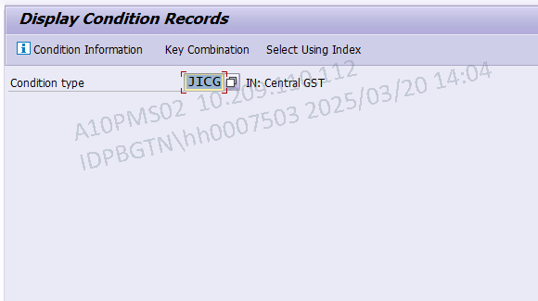

1. Select the first radio button.

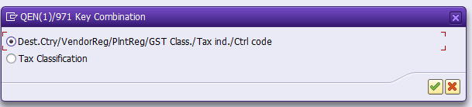

1. Enter the condition record details and remove the tick flag in **cond. marked for deletion** check box. Click F8

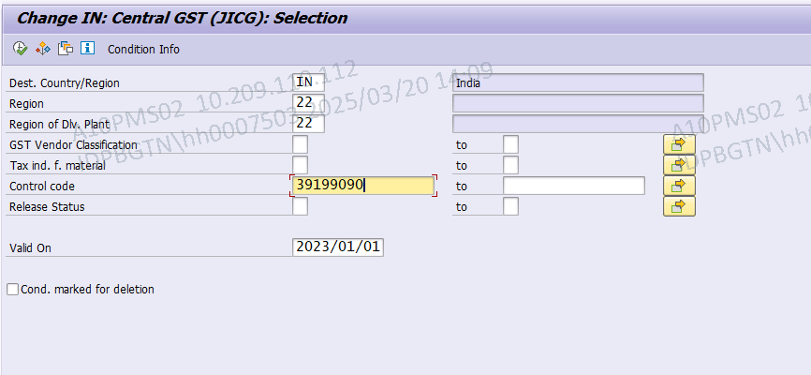

1. Red marked icon is the delete indicator marker..

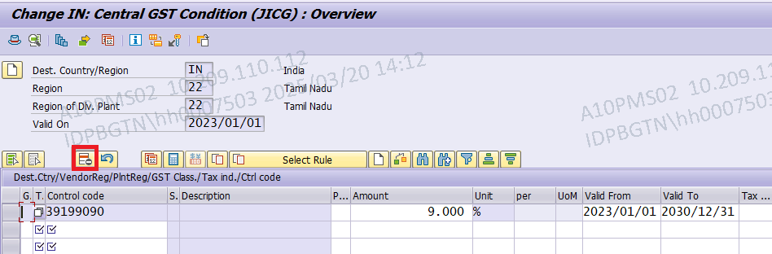

1. First select the record, click the delete indicator icon, and save. You have get delete indicator set message.

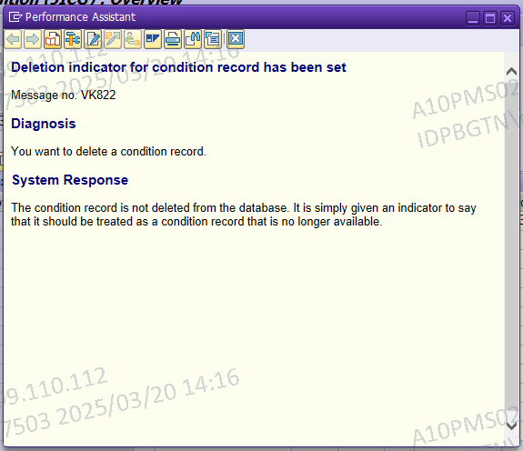

1. Go back and check the record.